|  |
| --- |
| Circle Language Spec: Events |

## Events Main Concepts

### Main Notation of Event

The main notation of an event is as follows:

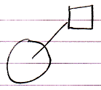

It shows an object with an event procedure / event command / event implementation associated with it.

### Event Connector

When an event procedure is not filled in, you will only see the event as a connector:

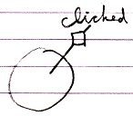

The reason for displaying it like this is that connectors usually look like the result of the system call, but then as a loose end.

### Event Raising

The object can raise the event. If you only see the interface of the object you will usually not see this, but if you can see the implementation of the object, its raising the event will look as follows:

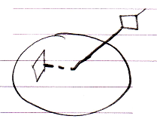

### Call to a Parent

An event is a way for an object to call its parent. So this is what that looks like:

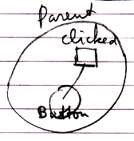

This is the reason why events are displayed like this in the diagram: it is like a child calling a parent.

### Event Implementation & Connector

When an event procedure is present, the connector to the event procedure is still available so that other procedures can be tied to the event:

